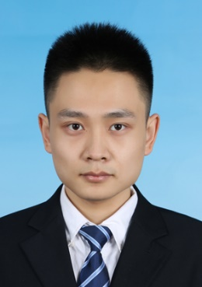**Liye Dong**

**(+86) 13021272833** **cufedongliye@foxmail.com**

**EDUCATION**

B.S. in Accounting, Shandong University (SDU), July 2015

M.S. in Finance, Central University of Finance and Economics (CUFE), expected in July 2019

Visiting Student, Nanyang Technological University (NTU), February 2018

**SKILLS**

IELTS 7.5, fluent in English

Proficient in SAS, Stata, and Microsoft Office

Certificate of Accounting Professional

**RESEARCH WORK**

**Does Environmental Regulation Affect Investors? Evidence from China's Action Plan for Air Pollution Prevention**

* Working paper Used event study to examine impacts of environmental regulation on stock market

**The Optimum Structure of Chinese Government Debt and Deficit**

* Project Report Constructed economic model based on stock market information, cooperated with International Cooperation and Capital Institute

**Air Pollution and Investor Gambling Preference: Evidence from Stock Market in China**

* Working paper Discovered the influence of environment on market trading and returns

**WORK EXPERIENCE**

2014.1-2014.2 **Lobby Manager Assistant in Industrial and Commercial Bank of China**

* Learnt to use the banking operating system, managed data analysis and collection process, and produced progress reports to a senior manager

2017.7-2017.9 **Trust Business Intern in SDIC Taikang Trust Company**

* Understood and followed existing procedures in the management and administration of the Trust’s affairs. Assisted managers to conduct due diligence investigation and design trust products

2017.7-2017.9 **Research Assistant in Nanyang Technological University**

* Assisted in data collection and processing, used financial methods to conduct analysis and paper writing

**PROJECT EXPERIENCE**

2012.6-2013.9  **Summer Social Practice**

* Topic：《Financing Constraints on SMEs and Solutions》
* Successfully led a team to finish two school-sponsored two-month field surveys

2012.9-2013.6 **National Undergraduate Training Program for Innovation**

* Topic：《Corporate Governance of Industrial Firms in Transition Economies》
* Data collection, data analyses and report writing

2017.12-2018.12 **CUFE Research Foundation of Innovation for Graduates**

* Topic：《Air Pollution and Investors’ risk preference》
* Projected to finish related research following the submitted proposal

**HONORS**

2012.9 Advanced Individual in Social Practice

2013.9 Excellent Survey Report of Shandong University

2013.10 University-level Scholarship in Social Practice

2014.4 Outstanding Member of the Communist Youth League

2014.10 First Prize for School’s Case Analysis Competition

2017.6 Beijing Joint Research Training Scholarship

2017.9 CFA Access Scholarship

2017.10 CUFE scholarship of Academic Excellence